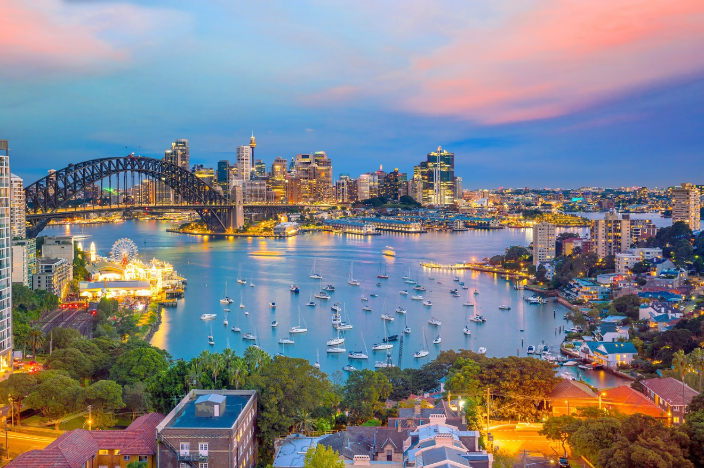

Statistical Analysis

Tourism Research Australia

Nachiket | s3827657@student.rmit.edu.au

Usability Engineering | 13th May 2020

# What quantitative data is provided?

* 1. Using table 2a from IVS results, it can be observed that even though education covers only 6.79% of the total visitors, the total trip expenditure is 29% just shy of the 38% expenditure on holiday

Figure 1 – Graph showing international visitors by reason for visit

Figure 2 – Total Trip expenditure by reason for visit

* 1. Table 6b shows annual expenditure by different visitor categories. Here it can be seen that apart from education students spend most on package tours and items for use in Australia when compared to holiday visitors

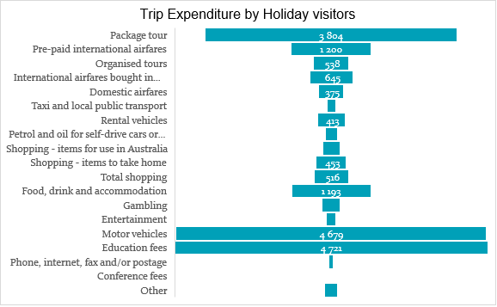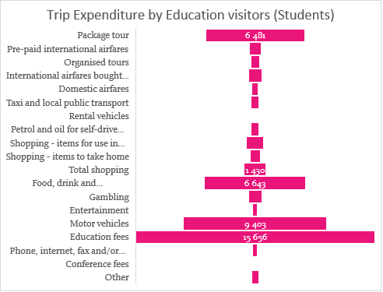Figure 3 – Expenditure made by education visitors

Figure 4 – Expenditure made by visitors visiting on a holiday

* 1. China and India have the highest median and average nights stayed while China and US have the highest average expenditure per night

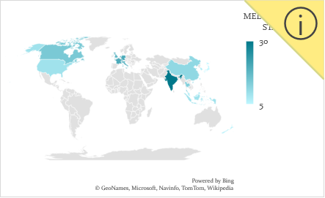

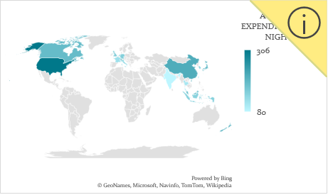 Figure 5 – Median nights spent by different countries

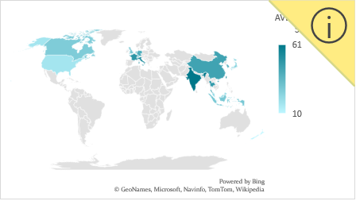 Figure 6 – Average per night expenditure by different countries

Figure 7 – Average nights spent by each country

* 1. Highest number of visitors come from China and New Zealand while China accounts for the highest spend by a country as observed from table 1a

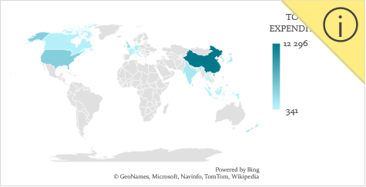

Figure 5 – Total trip expenditure by different countries

Figure 6 – Percentage of international visitors by country

# What qualitative data is provided?

* 1. While international visitor numbers remain stable, Australian tourism industry struggles to attract domestic visitors. Reasons stated in the Article on page 6 of the TRA report include 30% of Australians born overseas who travel internationally to meet friends and relatives. Technology is also observed to be a disruptor in this area with younger generation exposed to the international destination through #wanderlust and influencer movement on social media.
  2. Page 14 primarily talks about inclusive tourism. A greater market segment can be captured by catering to the accessibility needs of the visiting population. An example is provided where a wheelchair bound individual would not prefer visiting if the information about the available amenities concerning his needs are not publicized thus reducing the number of visitors in that category.
  3. Regional areas have comparatively a smaller number of visitors as observed in Table 10a and 10b. An analysis on this is provided on page 14 wherein the report talks about the challenges which include labor shortages, vast distances between regional cities and a lack of awareness on the offerings of regional Australia

# How comprehensive is the data? Any missing data found?

The data as well as the data analysis is exhaustive. The report covers a broad range of attributes and appropriately disseminates them into segments categorized by state, country, type of visit, expenditure (spend) and visitor nights. However, there are certain aspects that the report fails to elaborate upon –

1. The IVS result excel sheet does not include the data on tourism workforce. TRA report talks about the hurdles in securing a workforce in the tourism sector namely – low pay, unfavorable hours, low percent of skilled workers. An interesting correlation could have been made between this and the large number of student population that reside in Australia who depend on jobs to sustain their living.
2. The age range is not explicitly specified in the TRA report or the IVS survey. The estimates are given for visitors aged 15 and over. A detailed analysis categorizing visitors by age and cross referencing that with main reason for visiting Australia would have made an interesting segment to be included in the TRA report.

# Profit in 2018 vs Profit in 2019. What does the report say?

On page 5, the TRA report says that there was a slight increase (up 3%) in visitors in 2019 with a slightly greater increase in expenditure (up 5%). Upon observing the excel sheets, there isn’t any remarkable increase in any of the factors from 2018 to 2019, the percent increase numbers varying from 1 to 7% as well as occasional minimal percent decreases.

Figure 7 &8 – Comparison on regional trip expenditure and visitor nights for 2018 and 2019

# Support the assertion

On page 11, TRA report acknowledges the importance of sustainability. The report categorizes sustainability into 3 main types – Economic, Environmental and Community. All these types are interrelated and a focusing on a sustainable approach will support superior infrastructure which will bring in more profits for the tourism industry.

Page 15 provides 2 examples of the consequences of increased environmental as well as cultural sustainability awareness. Box 8 talks about providing commercial permits to only those operators who possess eco-tourism certification. Box 9 is about shutting down the climb to the top of Uluru to safeguard the cultural significance of the monument for its traditional owners. To compensate for the loss in tourism that might arise due to this, the region has established newer experiences that contribute to educating the visitors as well as allow them to experience the area in a new way.

However, acknowledgement and awareness does not always translate into tangible results. On page 14, increase in demand on experiencing indigenous culture is not enough to increase the already low visitation. According to the report, only 6% visitors have visited an aboriginal site.

# Is there any information in this report which could be of interest to a user?

Figure 9 (refer appendix) detailing the variance in occupation rates based on the time of the year is informative from a tourist perspective. At a glance, a novice tourist immediately understands that ski-season lasts between July to September suggesting the right time if that is the type of vacation one might want to have. The graph also lists 2 important holiday seasons.

Boxes 8 and 9 on page 15 increase awareness among tourists reading this report on the environmental and cultural aspects while planning a trip to the great barrier reef or the Uluru. The tourist might then look for eco-tourism certified guides to ensure that he/she are guaranteed to have an environmentally safe trip.

Figure 10 (refer appendix) is a great recommendation for a first-time tourist visiting Australia as it lists all the primary tourist locations.

Figure 11 (refer appendix) shows a list of tourism regions and the average spend per night for those regions. This could be particularly helpful for tourists looking to budget their vacations and help them plan the location of their trip based on their expenditure limit.

# What information does the report provide about technology and disruption?

Technology that has impacted tourism can be broadly divided into these main categories –

1. **Social Media** – Seen as an excellent platform to advertise (with countries like US and UK spending more and more on social media advertising), social media enables small and local businesses to communicate with their customers and respond quickly. In the next 5 years, social media is predicted to have an enormous role in decision making of domestic travelers.
2. **Sharing Economy** – Platforms such as Airbnb and Uber have significantly impacted the tourism industry and helped streamlined transactions, lower costs and provide a large range of offerings. Box 5 talks about hoteliers adapting to the sharing economy by offering rooms via Airbnb to diversify their customer base as well as attract younger tech savvy tourists.
3. **New Payment platforms** – Seen as a direct consequence of sharing economy and driven by the increasing need for security, it is observed that nearly 80% of payments were done by card, 51% of Australian consumers prefer contactless payment methods.
4. **Visitor Tracking** – An upcoming field (impact to be observed in the next 10 years), visitor tracking can give tourists a more personalized approach by tracking their external device while travelling. However, there is little awareness (40%) about this and low knowledge and is primarily geared towards a younger audience.

# Include 2 research questions –

* 1. To increase or even maintain current numbers, TRA must plan to accommodate for the future. What argument does the report make in this regard?

Accommodating for the future includes several factors. Driving the tourism industry towards sustainability from both environmental and community standpoints (examples listed on box 8 and 9) to secure the longevity of important tourist attractions. Increasing awareness through advertising (box 7 which talks about Australia inc campaign which was highly successful) that not only serves the purpose of increasing appeal of the destination but also present accurate information for future travel. Embracing technology is another key aspect in planning for the future. Using social media as a platform to reach the teach-savvy visitor market, enabling visitor tracking to create a personalized experience, adapting to the sharing economy (box 5). The “what’s next” section of the TRA report, while acknowledging the need for shift towards a forward-thinking approach, provides an inadequate summary of the future plans that the industry plans to implement.

* 1. A key aspect of any tourism industry is the infrastructure. Give examples from the report to support this assertion.

A key example of infrastructure planning is provided in Box 6 that talks about building a new airport in Sydney to help ease the overwhelming pressure on Sydney International Airport. In particular, the box not only highlights on investment on infrastructure but also the timing of the investment as well as the target. One of the critical challenges faced by regional areas in attracting visitors is lack of proper infrastructure. While not much has been said on tis regard, it is highlighted on page 14 which states that a few regional areas have already suffered an impact as they were not ready due to infrastructure deficits. Provision of infrastructure to accommodate the growing adaption to technology is also an important category.

Technology Disruptors report talks about the adaption of new payment methods. Including digital wallets and NFC’s. Travel and retail sectors have grabbed this opportunity and already introduced popular online payment methods in their stores. Technological infrastructure innovations can also help in providing tourists with new experiences such as a personalized approach with visitor tracking and using AR and VR to let them see Australia in a different way.

# Conclusion

In summary, the TRA report provides an insightful in-depth analysis. The report highlights on sustainability by categorizing it into 3 aspects and providing relevant cases for each. A reference is made to the impact technology has had on the tourism industry and how one can adapt to this. Graphs focusing on number of visitors, visitor nights as well as expenditure made by each country as well as categorizing users into different types based on their spend. A few details that could have been included would be analysis made based on visitor age and a deeper look into catering to student population and a much clearer outlook on the profits.

Appendix A – Figures

Figure 9 - CHANGE IN OCCUPANCY RATES BY MONTH FOR AUSTRALIA’S TOURISM REGIONS, JULY 2018 TO JUNE 2019

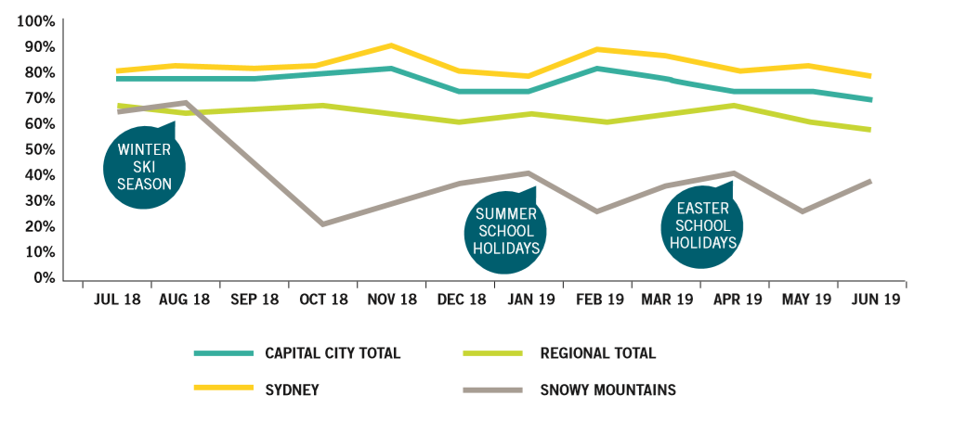

Figure 10 – INTERNATIONAL VISITOR GROWTH TO KEY NATURAL ATTRACTIONS, 2013–14 TO 2018–19

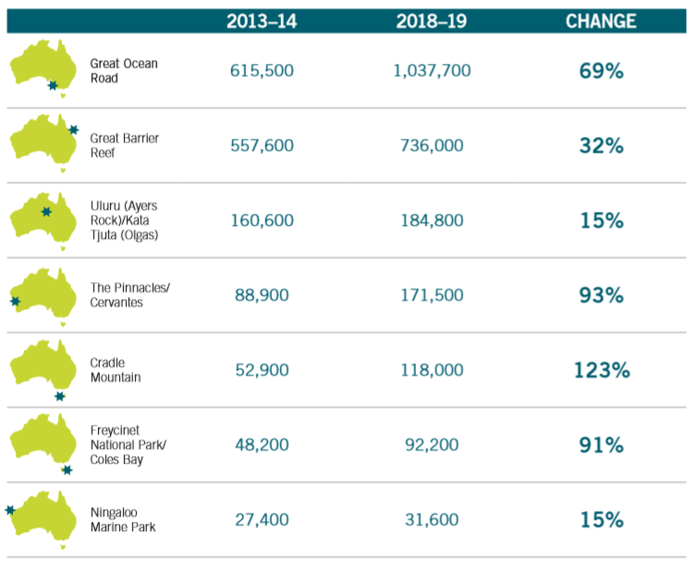

Figure 11 – TOP TEN TOURISM REGIONS BY AVERAGE SPEND PER NIGHT AND LENGTH OF STAY, 2018–19

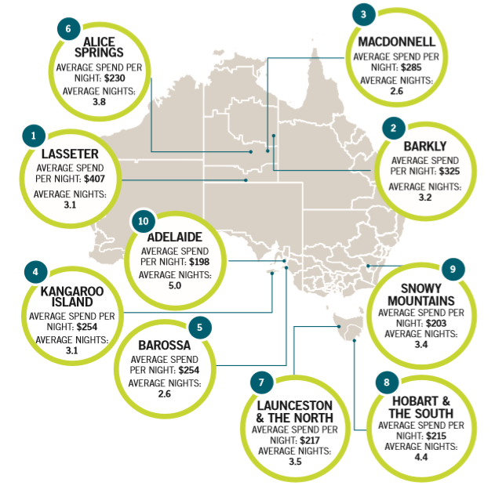

Appendix B – Tables

All the tables have been referred from IVS results excel sheet

* Table 1a - 1A INTERNATIONAL VISITORS, VISITOR NIGHTS AND TOTAL TRIP EXPENDITURE BY COUNTRY OF RESIDENCE
* Table 1b - 1B INTERNATIONAL VISITORS BY COUNTRY OF RESIDENCE
* Table 1c - 1C INTERNATIONAL VISITORS BY FIRST/RETURN VISIT, COUNTRY OF RESIDENCE AND MAIN PURPOSE a
* Table 2a - 2A INTERNATIONAL VISITORS, VISITOR NIGHTS AND TOTAL TRIP EXPENDITURE BY MAIN REASON FOR VISITING AUSTRALIA a
* Table 3a - 3A INTERNATIONAL VISITORS, VISITOR NIGHTS AND REGIONAL EXPENDITURE BY STATE/TERRITORY VISITED a
* Table 6b - 6B AVERAGE TRIP EXPENDITURE BY ITEM OF EXPENDITURE FOR INTERNATIONAL VISITORS BY PURPOSE OF VISITING AUSTRALIA a
* Table 9b - 9B INTERNATIONAL BACKPACKER VISITORS AND VISITOR NIGHTS BY TOP 30 REGIONS ac

References

1. Tourism Research Australia, State of Industry 2018-2019, Australian Government
2. Tourism Research Australia, International Visitor Survey 2019, Australian Government
3. Tourism Research Australia, Technology Disruptors in Tourism, Australian Government.